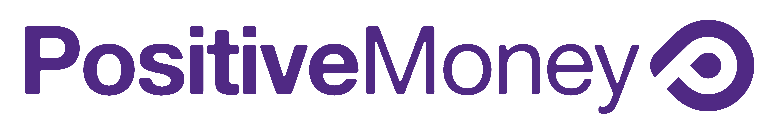
Growing our movement - one sign up at a time
Signing new people up to Positive Money is the most effective way of raising awareness of our campaign and growing the movement for money reform. Most people still have no idea that banks create the majority of the money in our system - it is our job to tell them!

We will not give flyers or resources to people unless they are going to a specific event. Handing a flyer to a random person on the street does not have an impact – it will most likely end up in the bin.

When a new supporter is added to the Positive Money mailing list they then receive our fortnightly newsletter - this means they will be kept connected to the campaign.

We receive more that 50% of our funding through monthly donations from people who receive our newsletter. The more people receiving our newsletter, the stronger our campaign will become.

Consequently, getting people to sign up to the mailing list is a top priority for all Positive Money events.

Top Tips
At a speaking event:
- Attach a sign-up form and pen to a clipboard. Send it round the audience during the talk and collect it at the end of the event.
- Before and after the talk, tell the audience there is a sign up sheet and encourage them to sign up.

Getting sign ups on a Positive Money stall:
- A friendly conversation is the best way to get people signed up. Asking people questions about whether they have heard of Positive Money and what they think of the banking system is a great way to start off.
- Giving people flyers when they don’t know what Positive Money will not end up with more sign ups, and will just waste paper!

After your event
Please send the sign ups to us, ideally typed into an excel spread sheet and emailed to mira@positivemoney.org (with name, email address and postcode in different columns), or sent directly to the Positive Money office.

Thank you - for helping raise awareness

