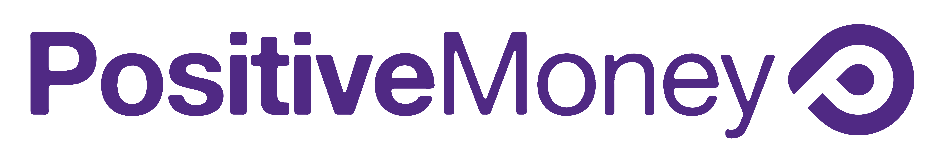

Growing our movement – one sign up at a time

Signing new people up to the Positive Money campaign is one of the most effective ways of raising awareness and growing our movement.

Most people still have no idea that banks create the majority of the money in our system - it is our job to tell them!

When a new supporter is added to the Positive Money mailing list they then receive our fortnightly newsletter - this means they will be kept up to date on campaign updates, new research and news from our network.

We receive more that 50% of our funding through monthly donations from people who receive our newsletter. The more people we have receiving our newsletter the stronger our campaign will become.

We are happy to provide flyers and resources for an event. However, we do not like to waste paper.

Please take the following points into consideration:

- Getting people to sign up to the mailing list is the highest priority

- A friendly conversation will always be much more effective than a flyer. Reforming the money system is a complex subject matter, a flyer is never going to fully convince someone to get involved with the Positive Money campaign

- When ordering flyers be realistic about how many you need – make sure they don’t end up in a box under your bed.

- We love feedback! If you find that certain flyers are much more effective than others, let us know.

Thank you for helping us raise awareness

